

**IHCI Second Project Submission**

**Project Group: A_G3_P2**

**HCI Group No: 3**

**Group Members:**

* 2024187: Dhruv Agarwal (Group Leader)
* 2024168: Daksh Kumar
* 2024111: Arsh Ahluwalia
* 2024150: Bhavay Yadav
* 2024130: Aryan Rana
* 2024205: Divyeh Chaturvedi

**Refined Requirement Gathering**

* **Refined Problem Statement**
* **Refined Solution /Scope**
* **Feedback Analysis & Improvements**
* **Refined Personas**
* **Refined Scenarios**

**(Links for all the resources are attached at the end)**

**Refined Problem Statement**

* Current healthcare systems **lack a unified platform** that integrates patient medical data,real-time monitoring, and emergency response.
* This fragmented approach often leads to delays in detecting and responding to **life-threatening medical conditions.**
* These delays result in **higher fatality rates** and poor patient outcomes
* Users struggle to quickly access specialized medical advice or consultations, especially in remote or underserved areas.

**Refined Solution**

* **Combining and unifying information** from a range of sources, such as wearable technology, imaging tests(X-rays, MRI, CT scans), family medical history, and electronic health records (EHRs)
* Using IoT devices to **continuously monitor health metrics** and detect potential issues.
* Enabling **real-time communication with medical professionals** and updates the user’s health status.
* **Coordinates emergency response** by locating the nearest medical facilities, and using drones for rapid delivery of medical supplies.

**Feedback Analysis & Improvements**

**Improvements made by Analyzing User Testing and Feedback Analysis:**

* Added a view “Medical Records” feature which stores the previous medical tests of the patient.
* Applied a “View Vitals” section in the app where one can see their vitals and get an idea of what's happening.
* Added a “Doctor rating and reviews” tab which helps people to judge the authenticity of the doctor.
* Integrated a Video Call feature and an AI feature which can automatically add the medicines which are prescribed by the doctor to the shopping cart.
* Added a “Emergency SOS” feature.
* Included a “Book Physical Appointment” tab.
* Used Rounded corners instead of Sharp corners to make the design aesthetically pleasing.
* Reduced the Cognititve Load and made the UI easy to understand.

**Refined Personas**

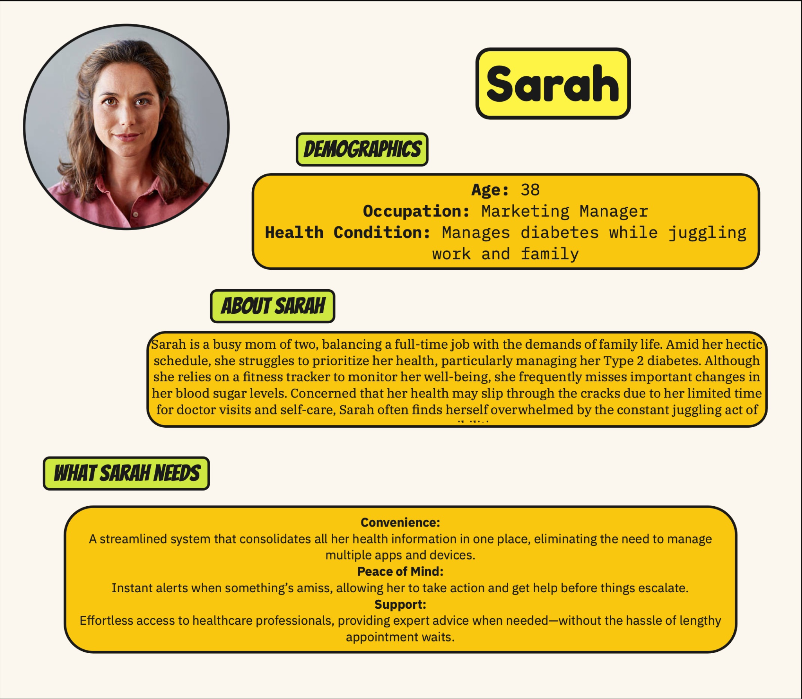



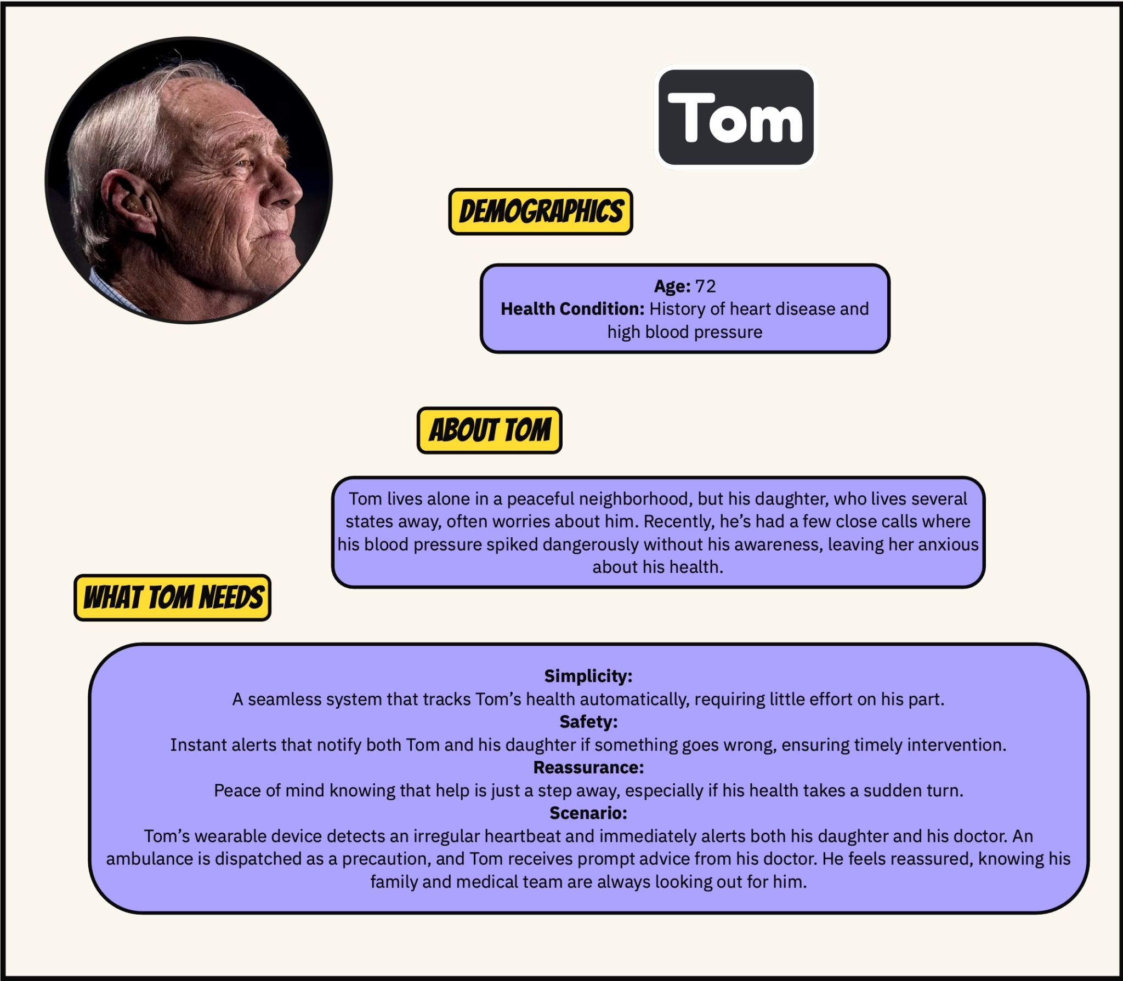

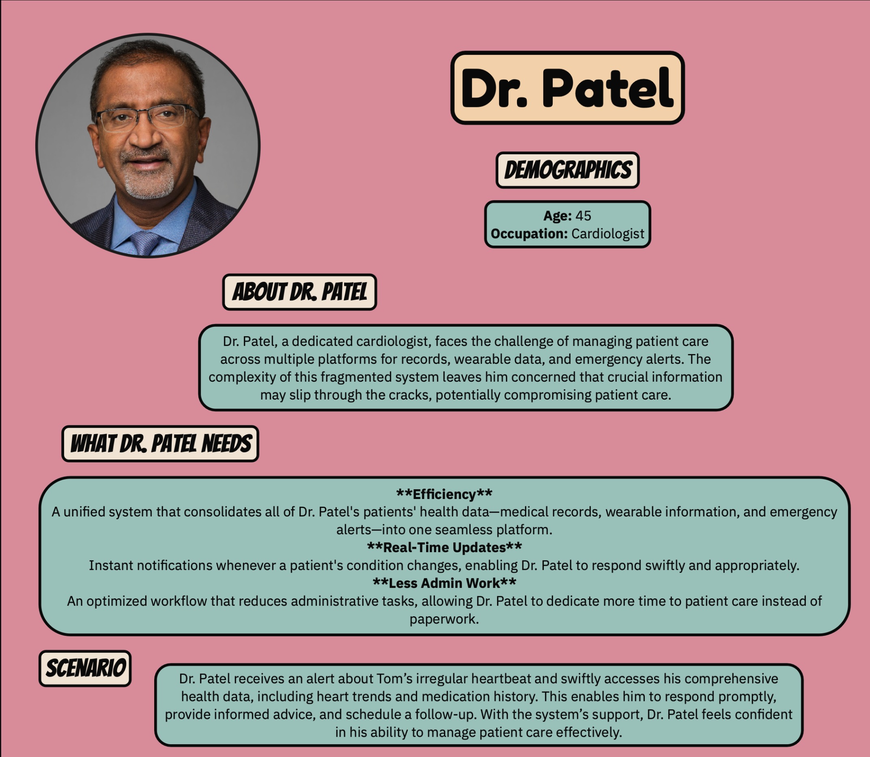

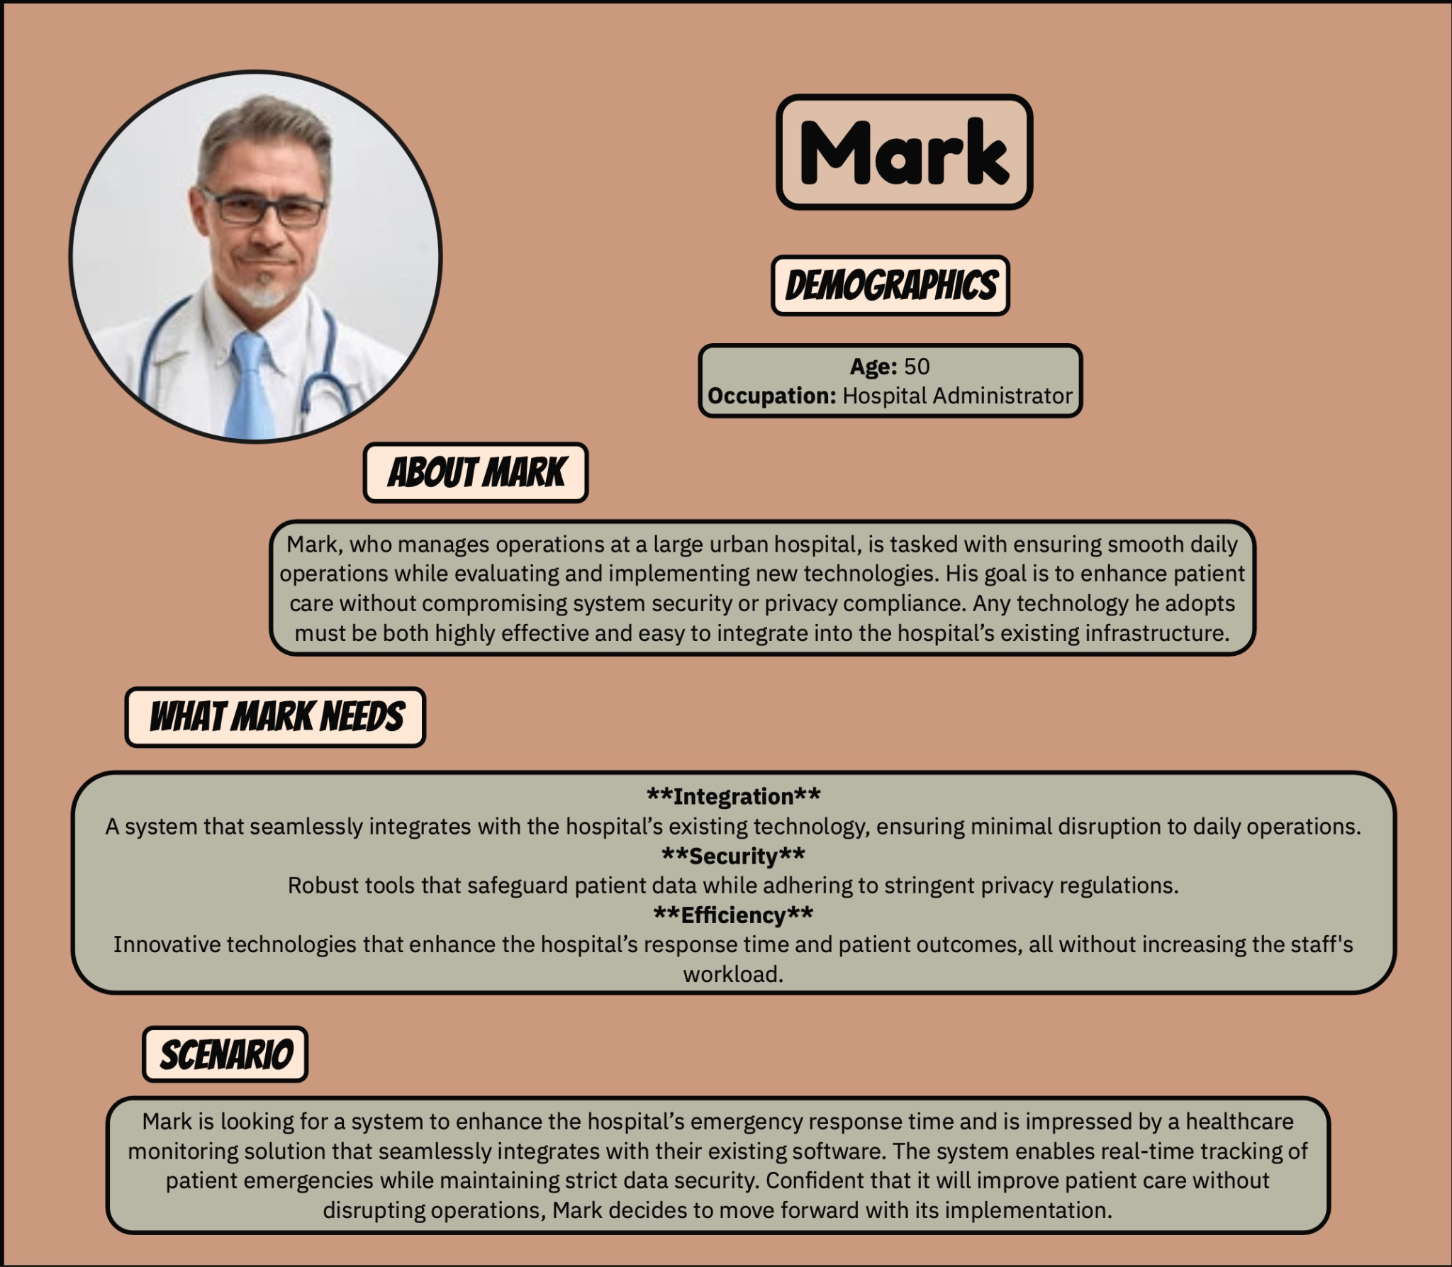

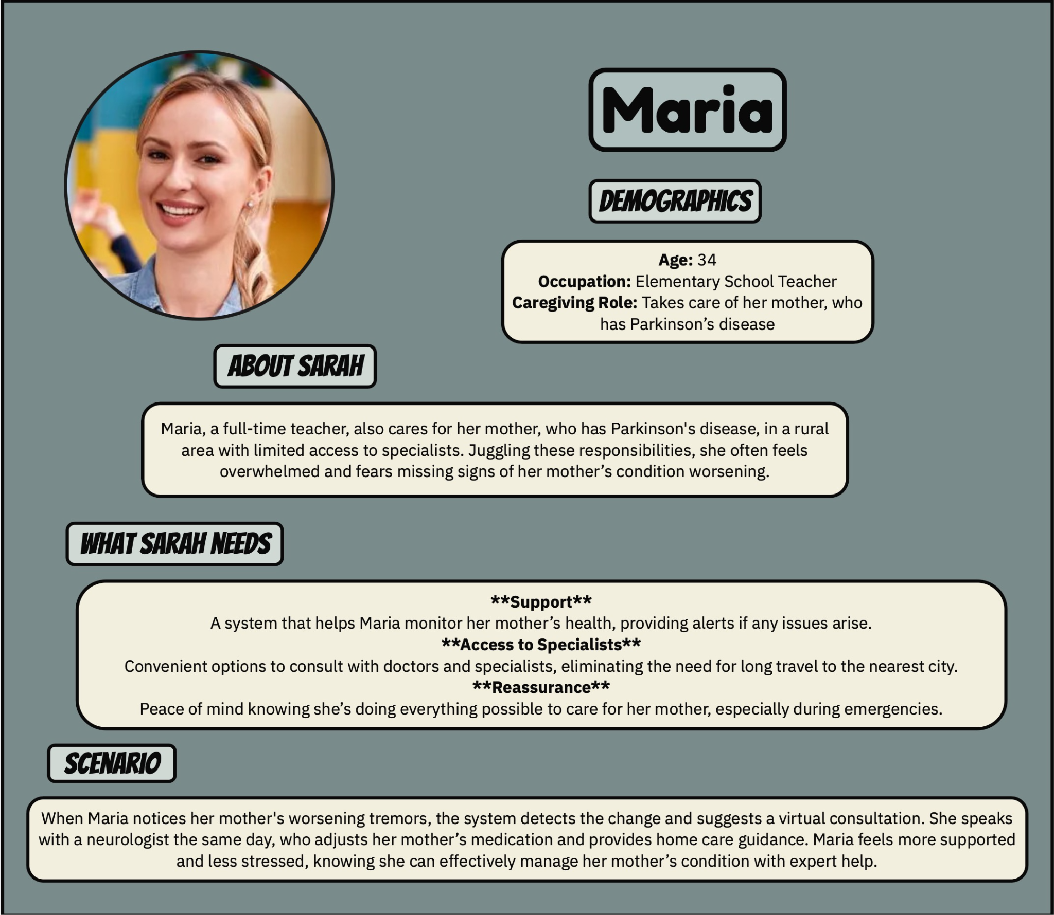

**Refined Scenarios**

**Scenario-1:**

Mohan, a resident of IIIT Delhi's hostel, maintains his health through daily exercise. He relies on an app called PreCure to monitor his well-being. PreCure tracks his steps and blood pressure throughout the day, providing a comprehensive report each evening. If any concerns arise, the app promptly alerts him and allows him to schedule an online appointment with a specialist. Additionally, PreCure keeps track of his caloric intake and offers personalized nutritional advice. Since incorporating PreCure into his routine, Mohan has successfully stayed healthy and fit.

**Scenario-2:**

Sohan, a web developer from Delhi, has been frequently visiting the doctor since his recent diabetes diagnosis. Struggling to manage all his medical reports and prescriptions, he downloaded an app called Precure. This app allows him to store medical records effortlessly by simply taking a photo or uploading documents. Since using Precure, Sohan has seamlessly organized his medical data, booked online appointments with specialists, and conveniently ordered prescribed medications through the application.

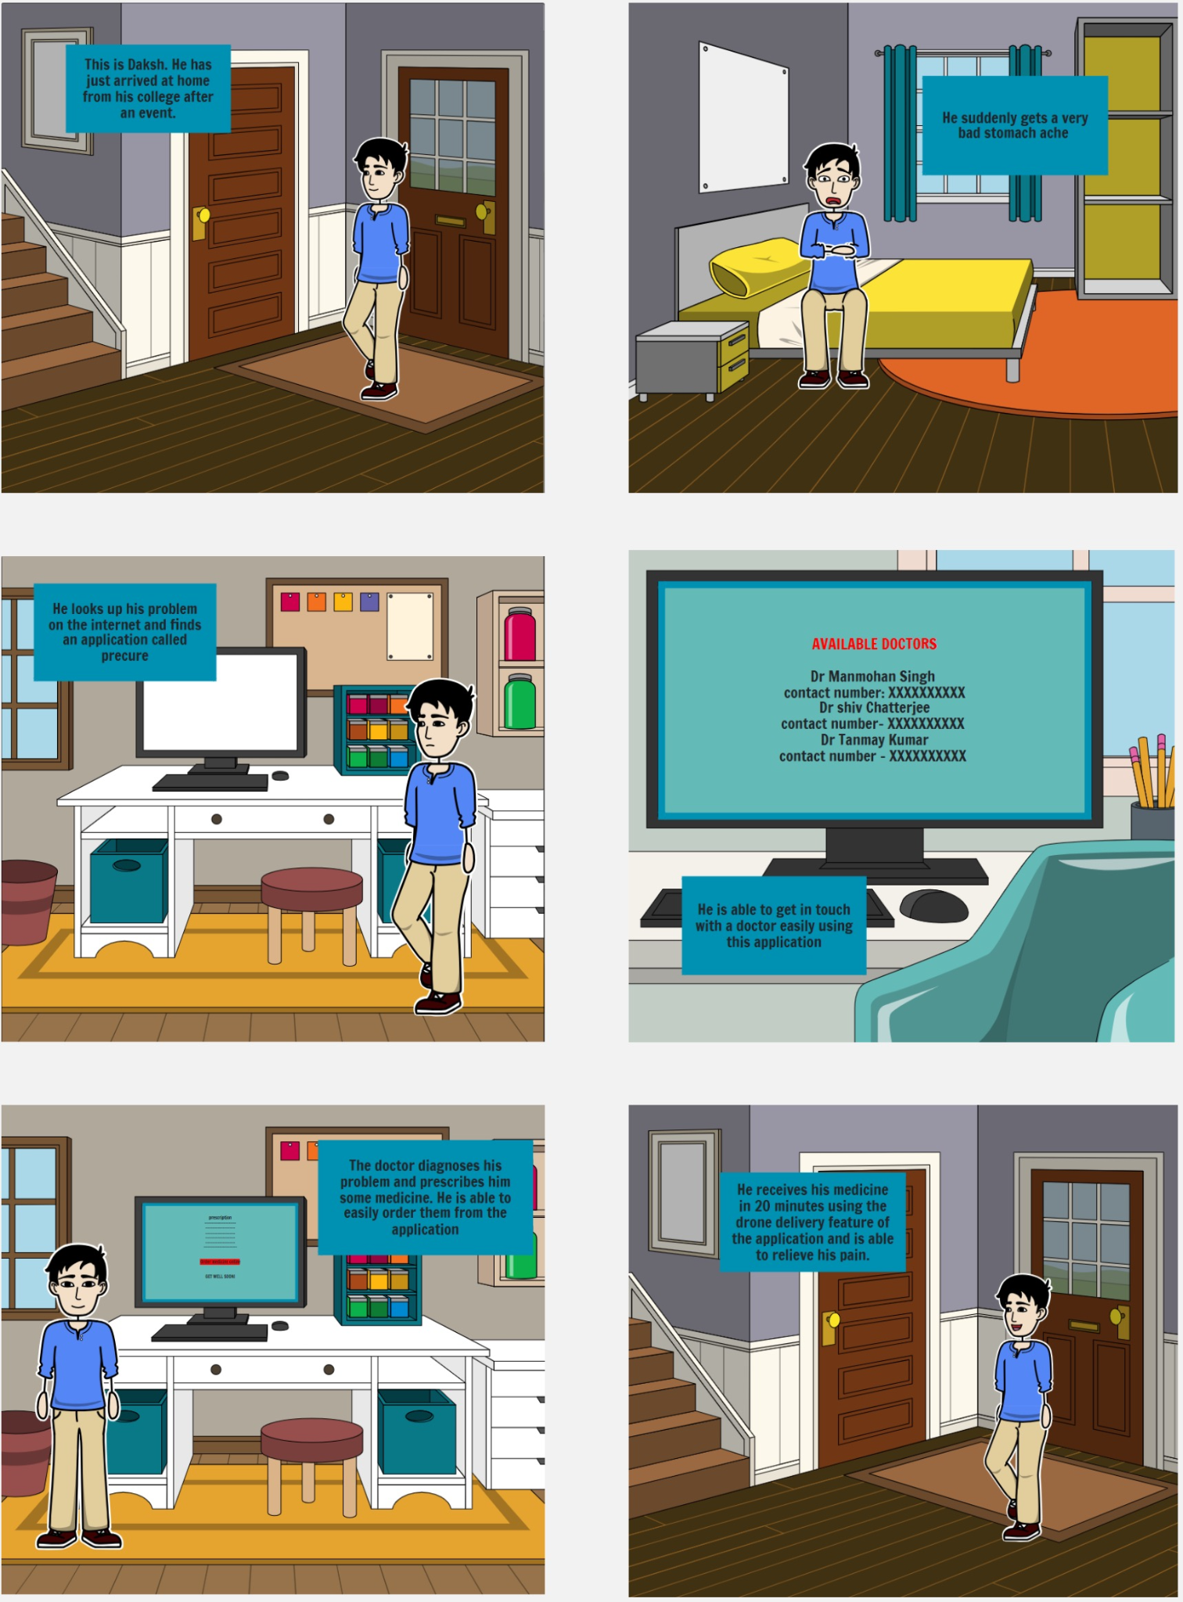

**Lo-Fi, Hi-Fi & Testing**

* **Refined Lo-Fi (Based on the Improvised Alternate Design)**
* **Hi-Fi Design**
* **Google Form Testing Responses**
* **Analysis of User Feedback**

**(Links for all the resources are attached at the end)**

**Refined Lo-Fi**

**Starting Screen , Login , SignUp , Forgot Password**

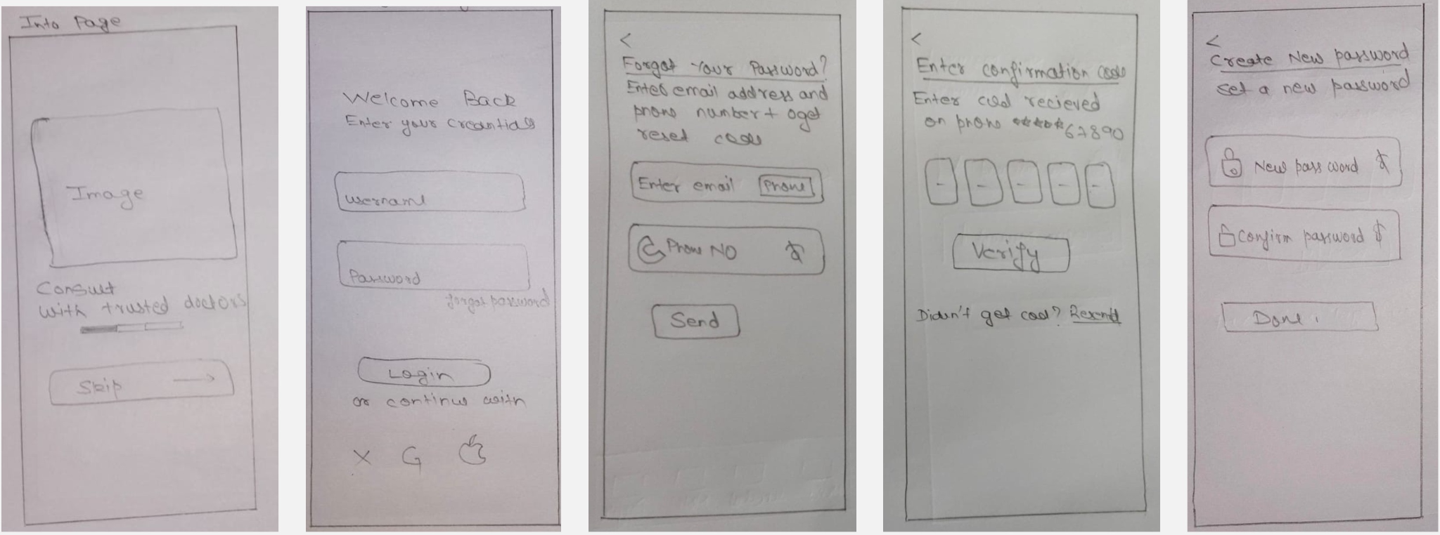

**Home Screen , Vitals , Profile , Schedule , Notifications , Medical Records**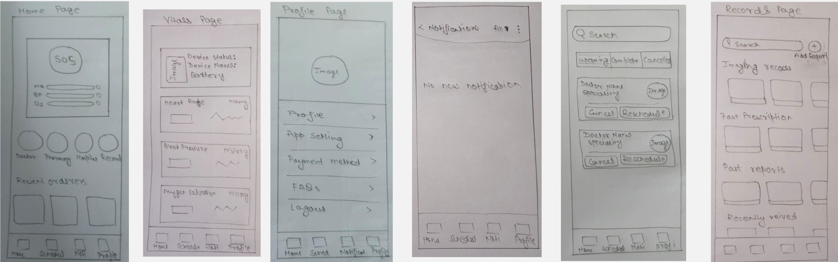

**Pharmacy Page (For Ordering Medical Supplies)**

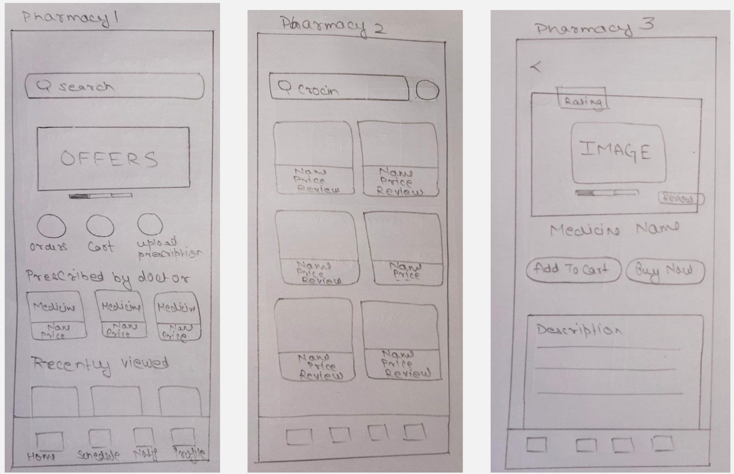

**Doctors Page (For Expert Consultation)**

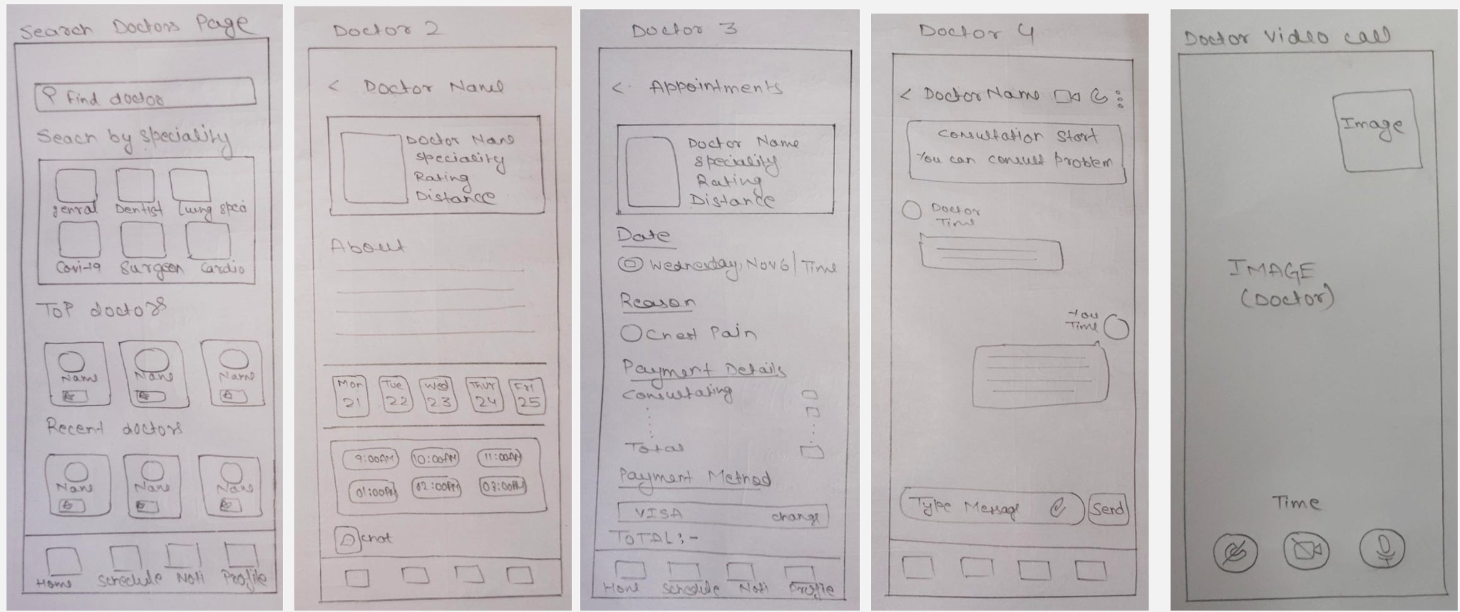

**Hi-Fidelity UI Design**

**Starting Welcome Screens**

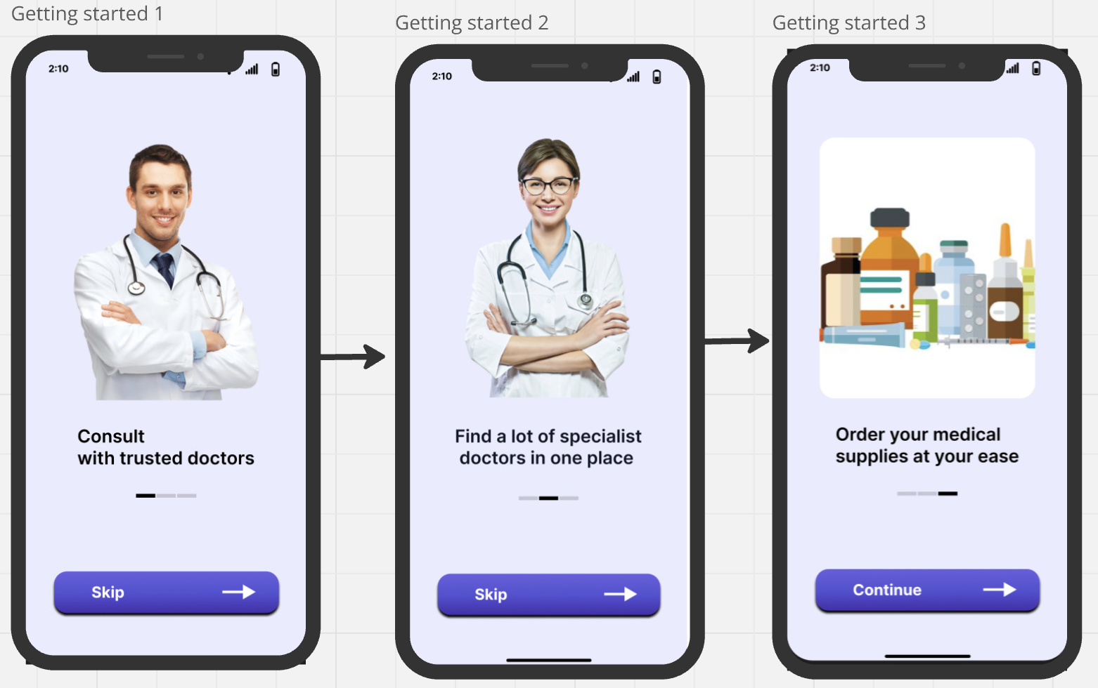

**Login , SignUp , Forgot Password**

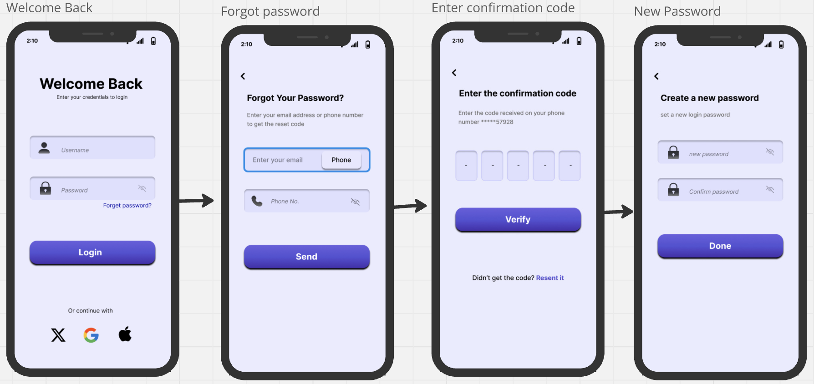

**Popups**

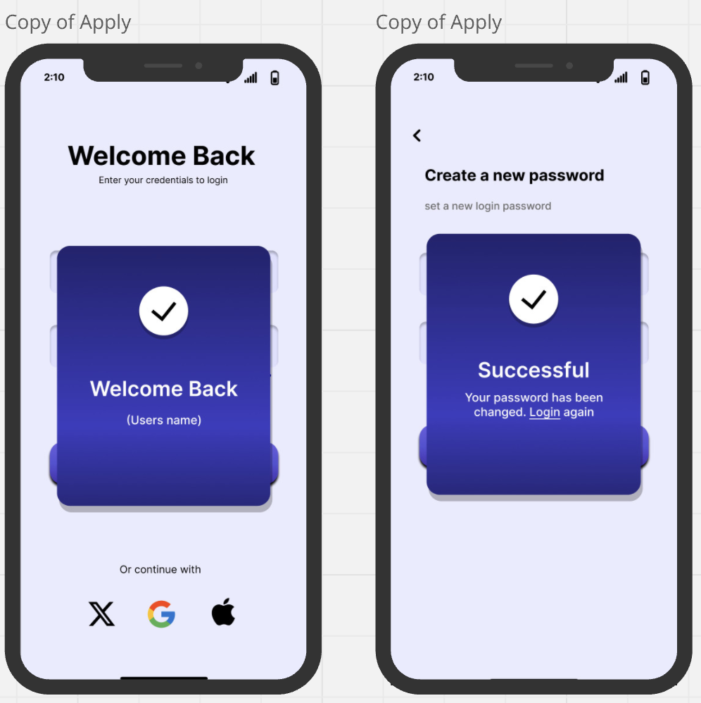

**Home Screen , Profile , Schedule , Notifications**

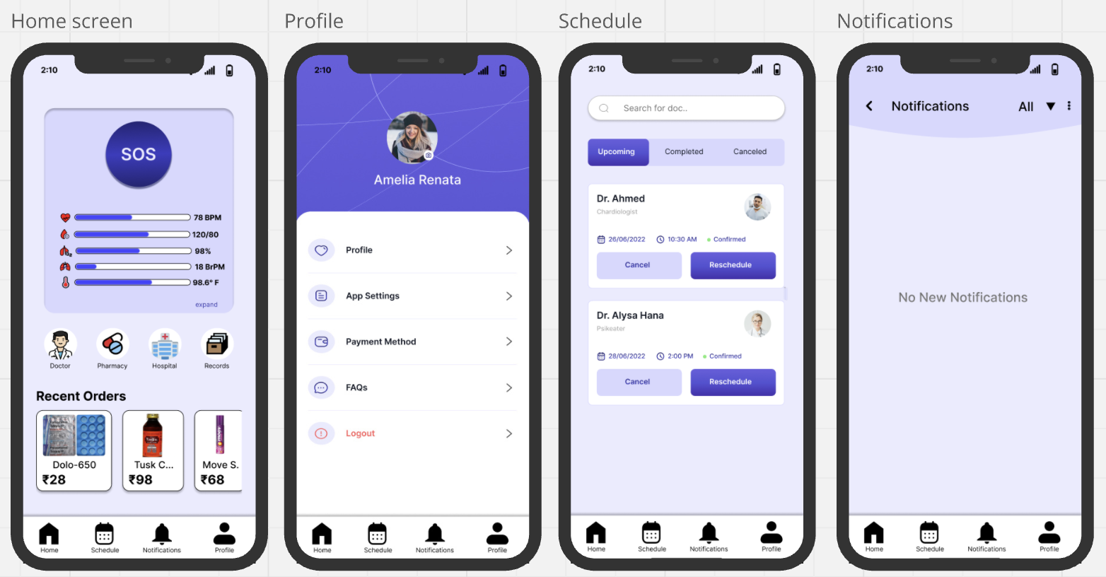

**SOS Popup , Vitals Screen , Medical Records**

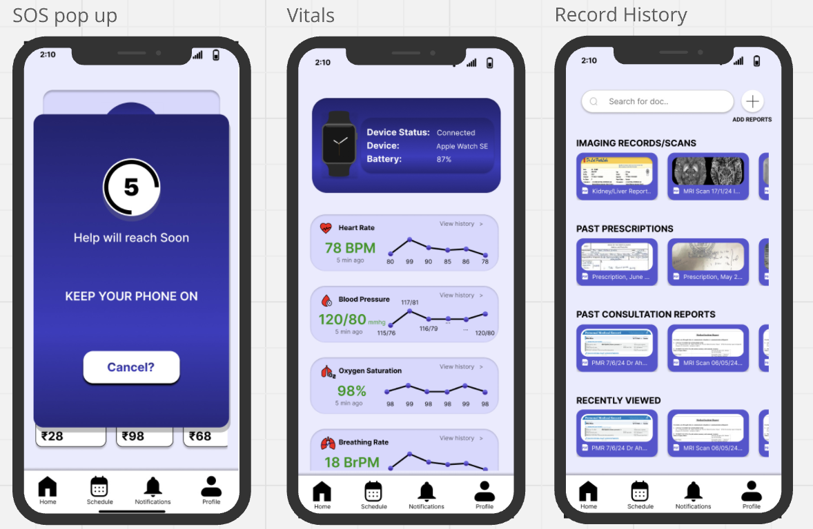

**Doctors Page (For Expert Consultation)**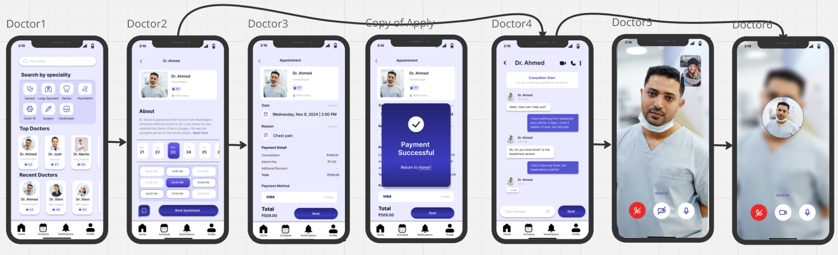

**Pharmacy Page (For Ordering Medical Supplies)**

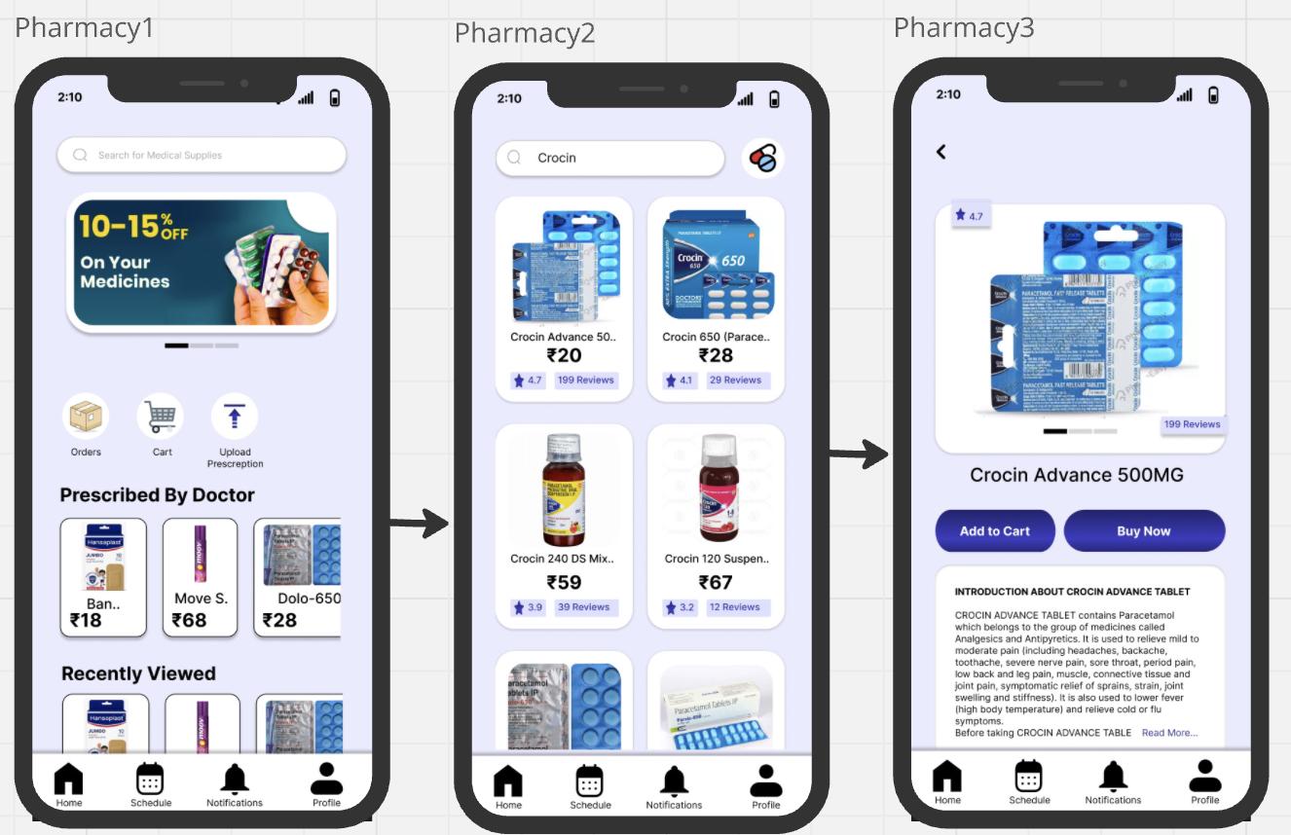

**Google Form Testing Analysis**

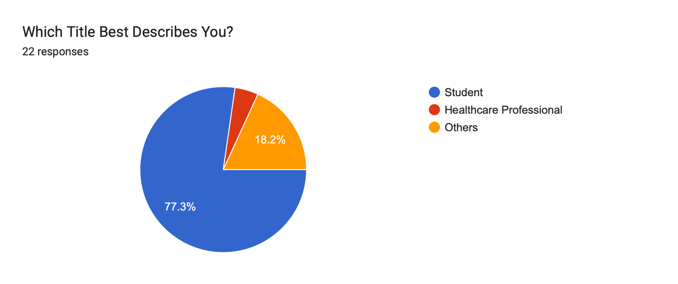

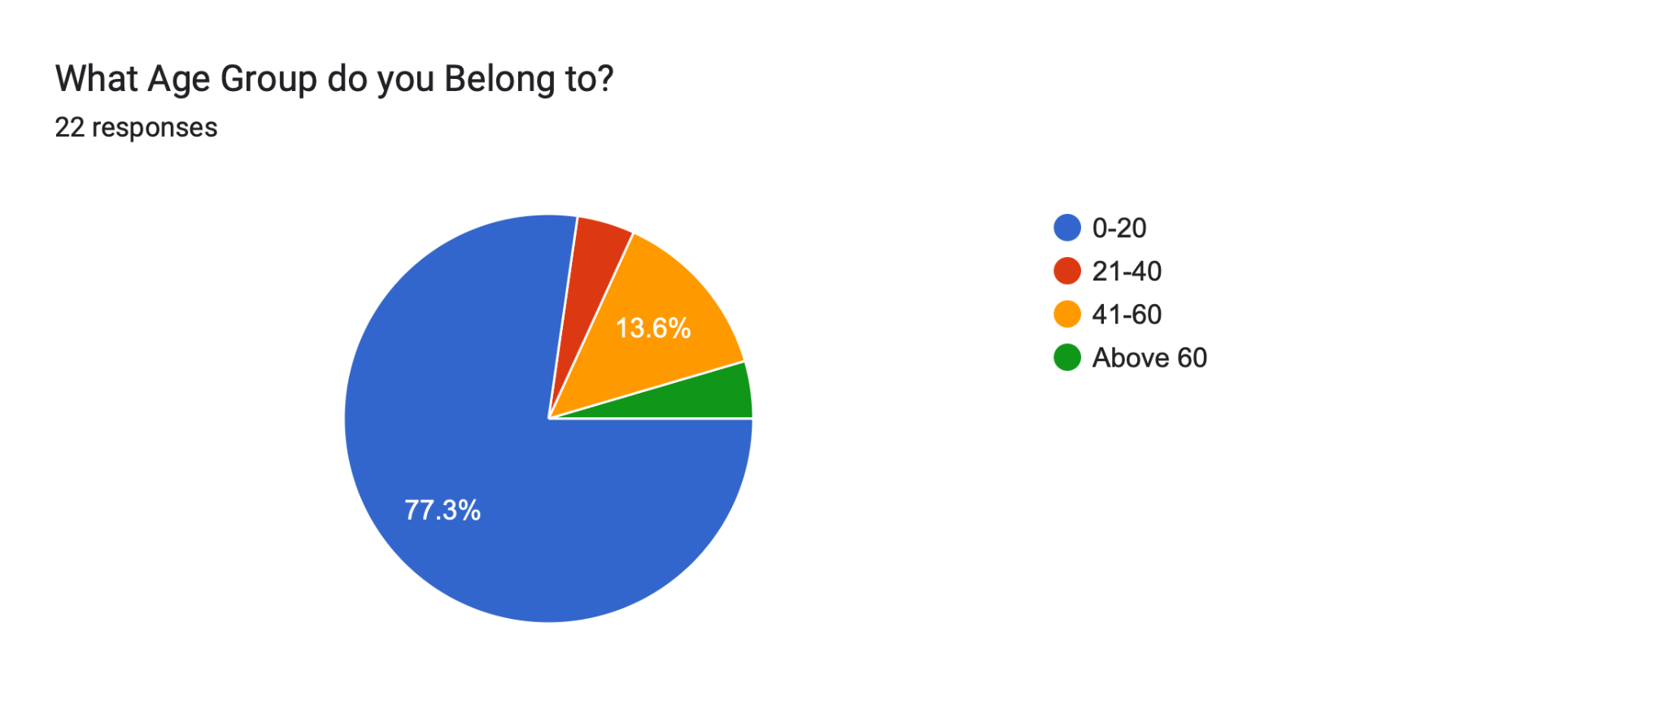

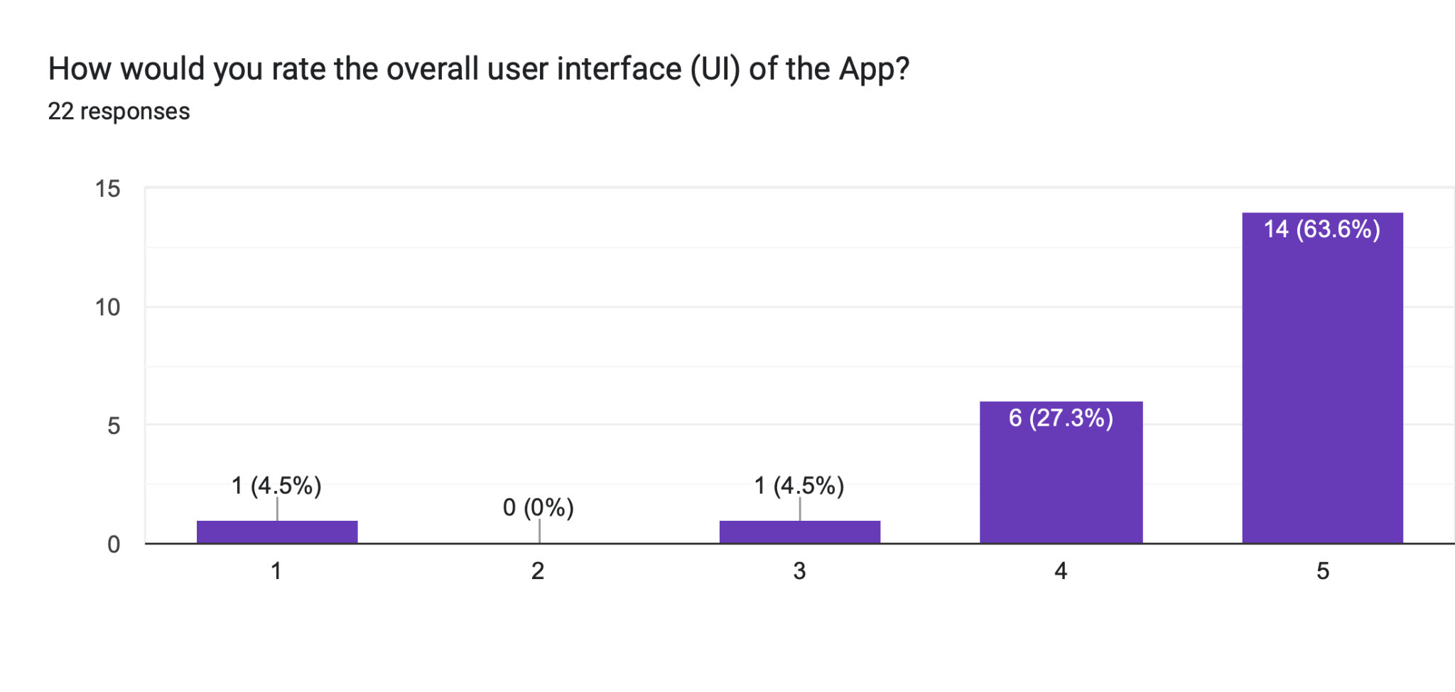

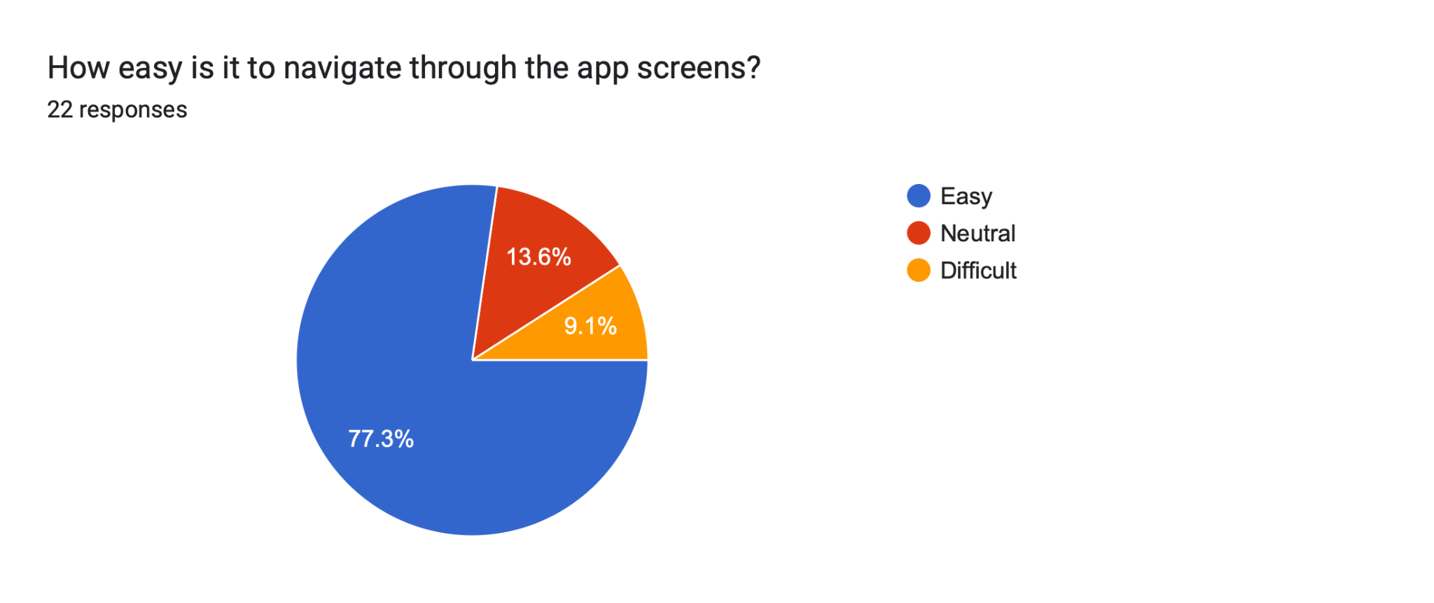

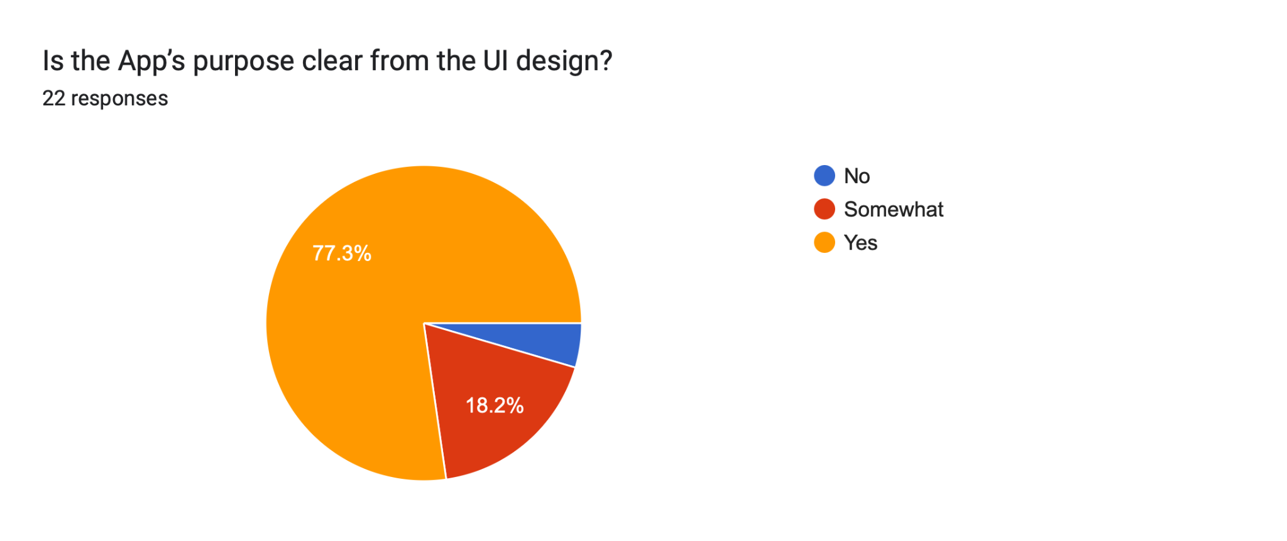

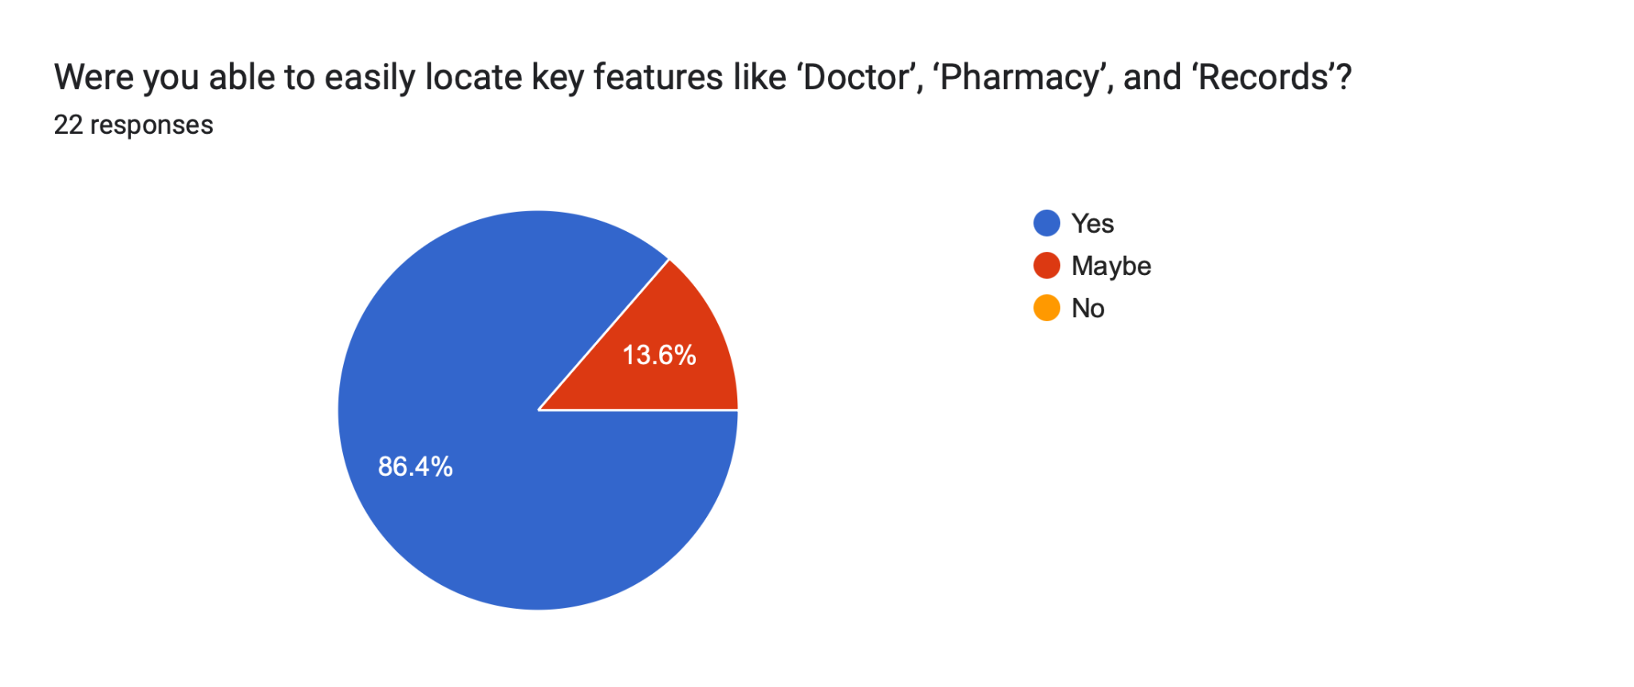

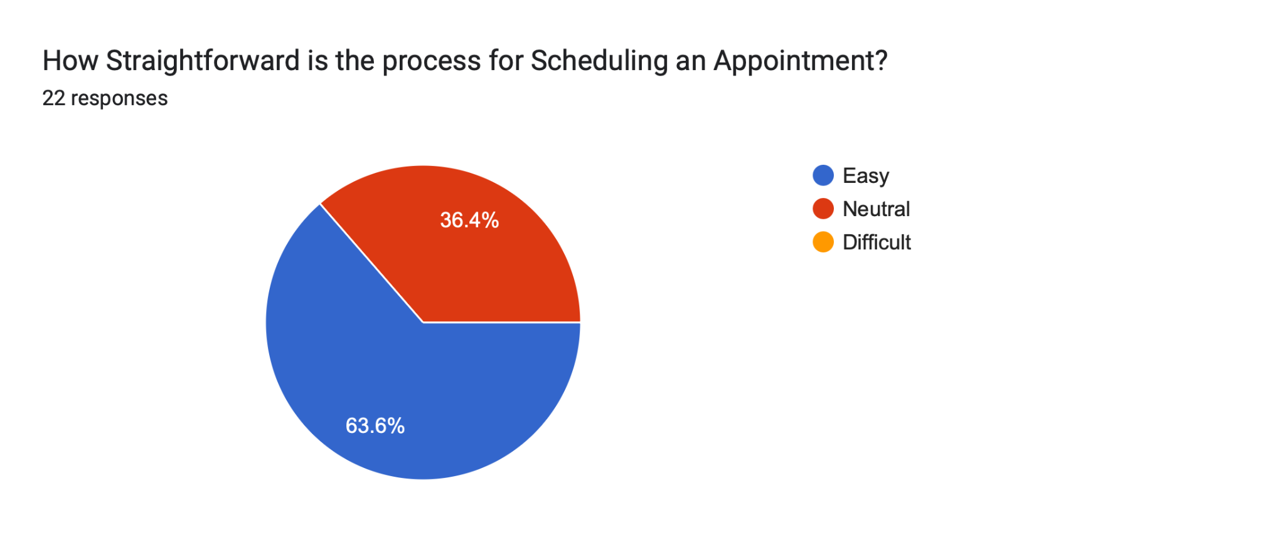

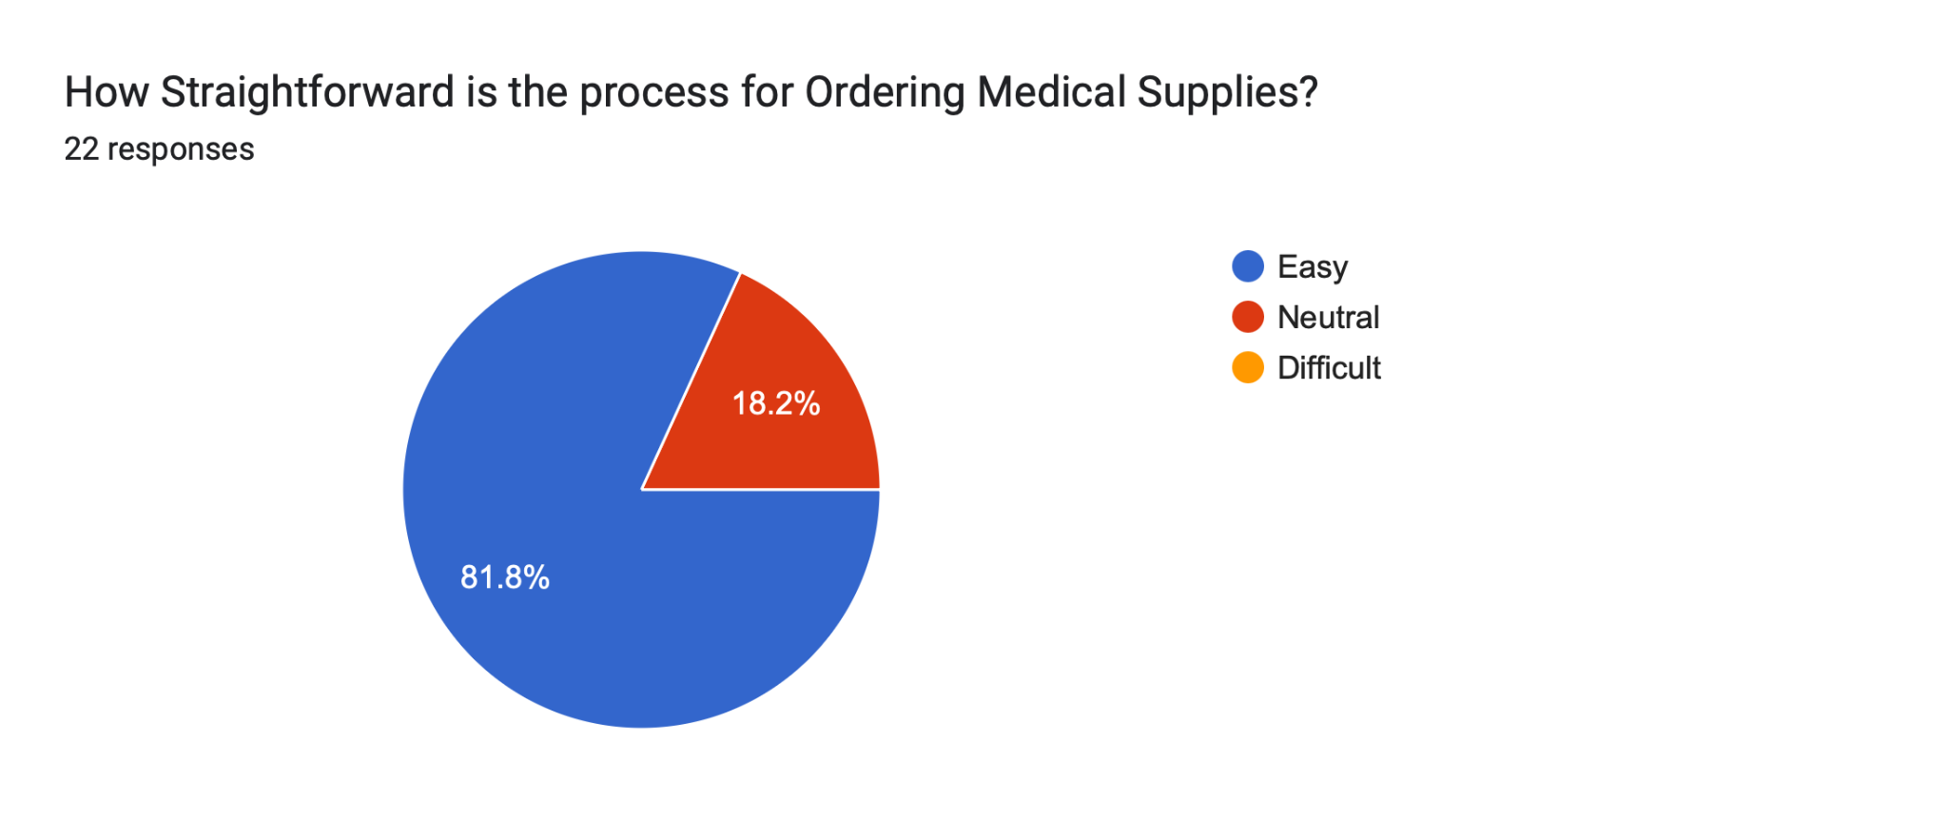

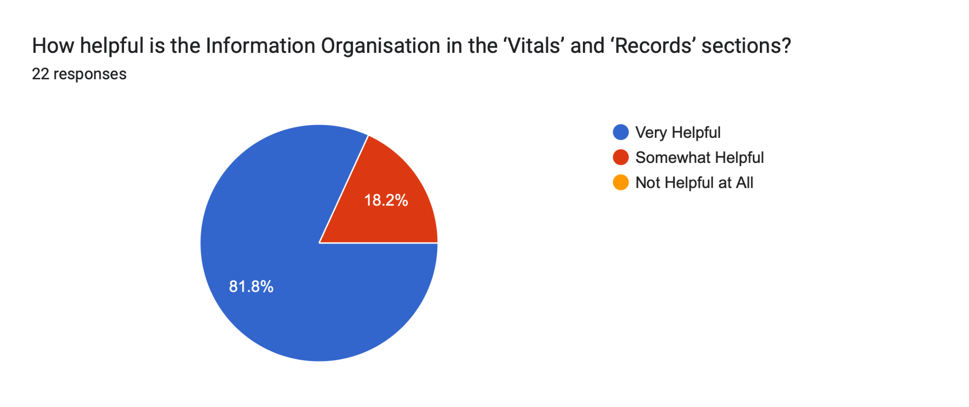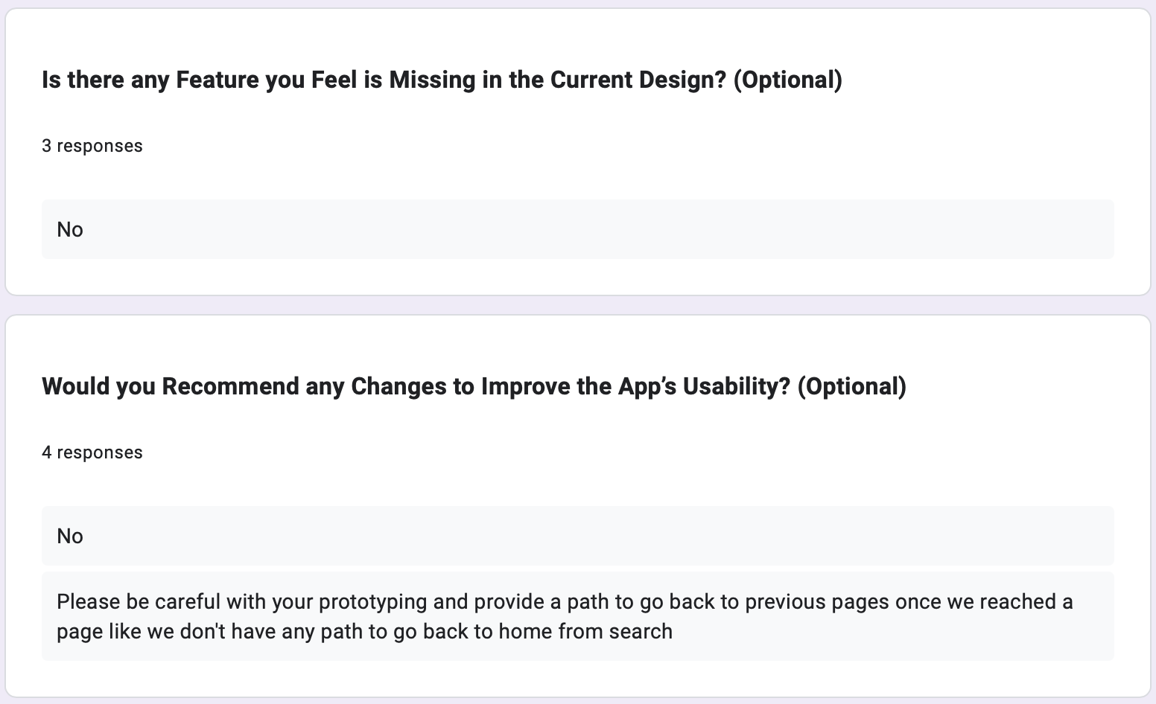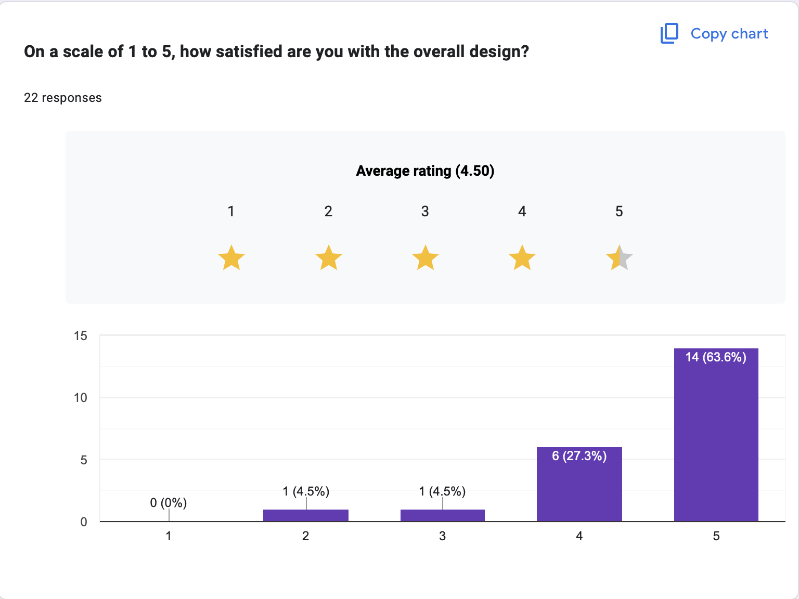

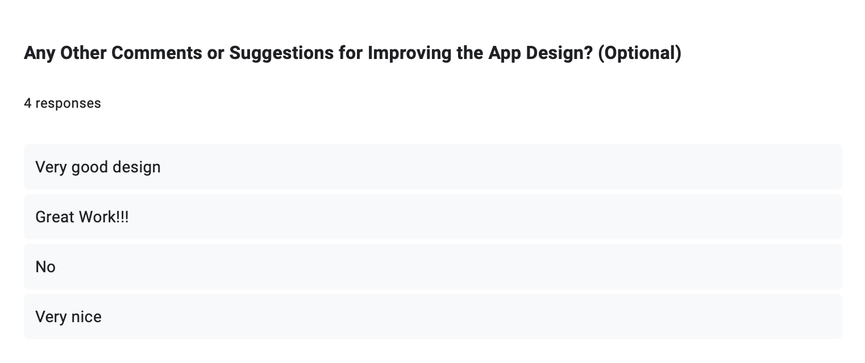

**Analysis of User Feedback**

**Overview:**

The survey collected feedback on the app's design and user experience, focusing on interface intuitiveness, navigation ease, and the clarity of features. The respondents predominantly belonged to the 0-20 age group, with a mix of students and a few participants from older age groups. The survey aimed to gauge the app's usability and gather suggestions for potential improvements.

**Survey Data Summary:**

**Age Group**: The majority of respondents (around 80%) were students in the 0-20 age group. A few participants from the 21-40 and above 60 age groups also provided insights, including healthcare professionals and others.

**User Interface (UI) Ratings:** The overall UI was well-received, with most respondents rating it between 4 and 5, indicating satisfaction with the design. A few respondents rated it lower, highlighting areas needing refinement.

**Navigation Ease:** Most respondents found the app easy to navigate, with a few rating it as "Neutral" or "Difficult," suggesting room for improvement in navigation pathways.

**Feature Accessibility:** Key features such as 'Doctor,' 'Pharmacy,' and 'Records' were easily located by most users. However, some users rated the ease of accessing these features as only "Somewhat," indicating potential areas for better guidance.

**Appointment Scheduling and Ordering Supplies:** Most respondents found the processes straightforward, although there was some variability, with a few rating these processes as "Neutral."

**Information Organization:** The 'Vitals' and 'Records' sections were largely seen as helpful, with some users suggesting minor improvements.

**Key Feedback Themes:**

**Missing Features & Suggestions**

* **Navigation Enhancements**One respondent emphasized the need for a "Back to Home" button for easier navigation.
* **Note: This was already present at the time of testing so we think the user might have not noticed which gave us another area to improve on**
* **Feature Improvements:** Suggestions included ensuring careful prototyping and providing clearer paths for screen transitions.

**Design Ratings**

* The average overall design rating was around 4.5, indicating high satisfaction but signaling room for additional fine-tuning.

**Conclusion:**

The survey results indicate that the app design is mostly intuitive and user-friendly, with strong ratings for UI and navigation. Key features were easy to locate, and most users reported straightforward processes for key actions. Nevertheless, a few respondents highlighted areas for improvement, such as enhanced navigation paths and additional features. Implementing these changes, such as clearer navigation and careful prototyping, could further enhance the app's usability and user satisfaction.

**Suggestions and Feature we said we will Implement:**

* **Doctor Calling Feature**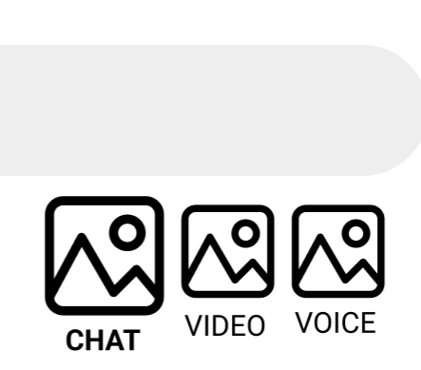

* **Adding Records**

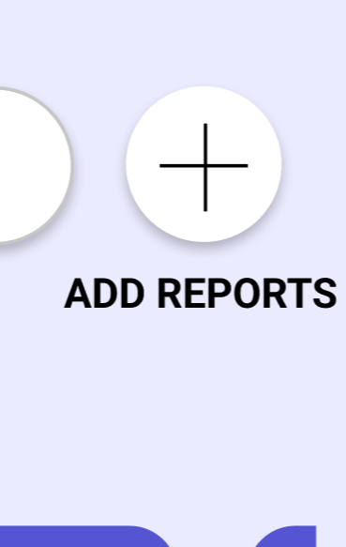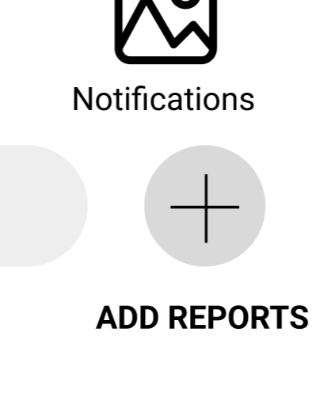

* **Doctor Ratings and Reviews**
* 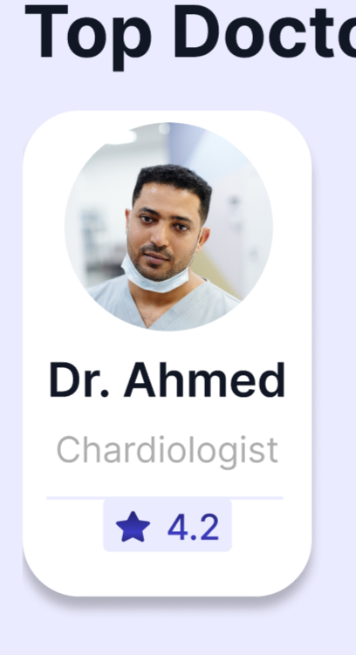

**The rating part which be shown in the suggested doctors part of the application**

**Whereas, the reviews will be showed in more details section of the application**

* **Finishing & Cognitive Load**

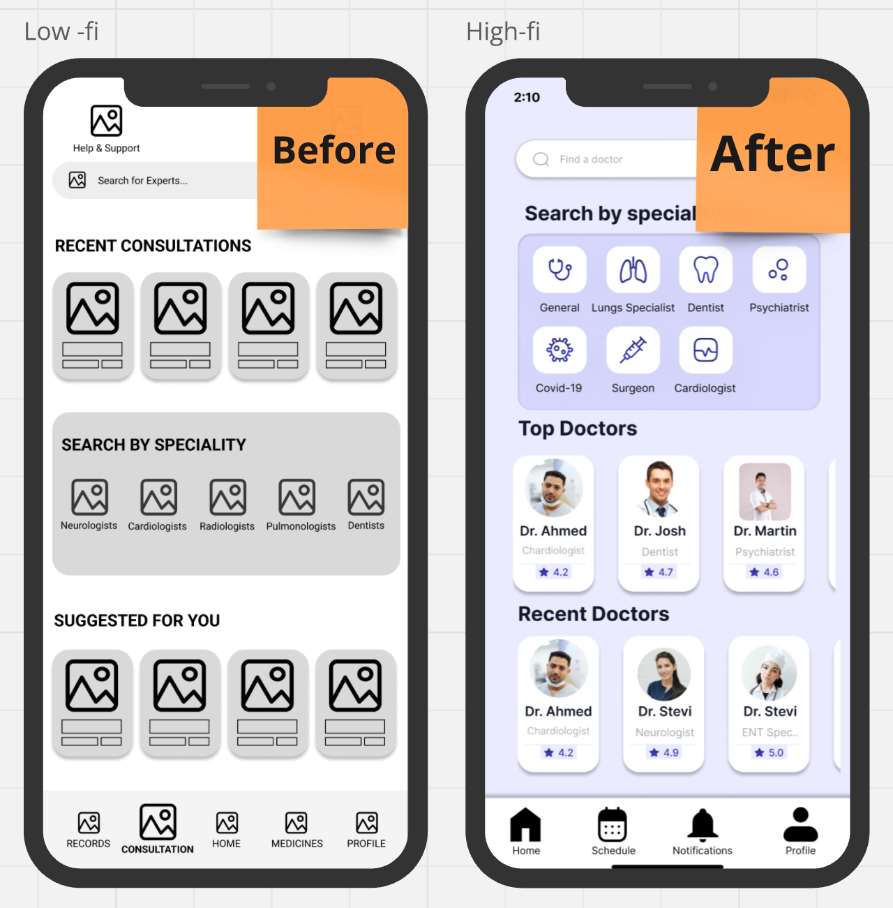

**Links:**

* **Figma Mid-Fi:**[**https://www.figma.com/design/m15Ww8bWzmLsPeqj2IaN8t/PreCure.WireFrame?node-id=0-1&t=ZDlPA07r6kSw5pgu-1**](https://www.figma.com/design/m15Ww8bWzmLsPeqj2IaN8t/PreCure.WireFrame?node-id=0-1&t=ZDlPA07r6kSw5pgu-1)

**Hi-Fi:**[**https://www.figma.com/design/SUVEG1YPXsDMCwfoLfeBTX/PreCure-UI-Design?node-id=0-1&t=MLdcOoqW9lWDtF5C-1**](https://www.figma.com/design/SUVEG1YPXsDMCwfoLfeBTX/PreCure-UI-Design?node-id=0-1&t=MLdcOoqW9lWDtF5C-1)

* **Miro(MentalModel,Use-CaseDiagram,Personas, Scenarios,Task-flow,Brainstorming,Mid-Fi):**

[**https://miro.com/welcomeonboard/anNHM044YVNjS1JtejRGbUtrTEdjb2RCQ1ByUGtHU3ZLek5sR0NqVktXSmVObVl5cnR3VVM5emFkSjVFNGJYMXwzNDU4NzY0NjAzNzk0MjYyNTUzfDI=?share_link_id=881725856044**](https://miro.com/welcomeonboard/anNHM044YVNjS1JtejRGbUtrTEdjb2RCQ1ByUGtHU3ZLek5sR0NqVktXSmVObVl5cnR3VVM5emFkSjVFNGJYMXwzNDU4NzY0NjAzNzk0MjYyNTUzfDI=?share_link_id=881725856044)

* **Hi-Fi Testing Survey(Google Form):**

[**https://forms.gle/E8iMUnFC8jDT2Fvm8**](https://forms.gle/E8iMUnFC8jDT2Fvm8)

**Individual Contributions:**

* **Arsh**
* Refined Scenarios
* **Aryan**
* Drew LoFi Images
* Miro Arranging HiFi Images
* **Bhavay**
* Refined Personas
* **Daksh**
* Hi-Fi Design
* High-fi Testing Analysis
* **Dhruv**
* High-fi Testing & Evaluation
* Compilation & Finishing
* **Divyeh**
* Refined Requirement Gathering